Curriculum Vitae

Rev. Dr. David W Larsen
Senior Research Fellow, The Kirby Laing Centre for Public Theology in Cambridge (UK)
Director, The Scripture Collective

970 Village Green Drive, Apt 203, Allen, TX 75013
Personal Cell: 972.467.9312

Personal Email: davidl@kirbylaingcentre.co.uk

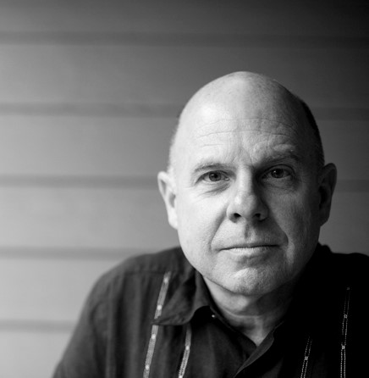

Academic Expertise and Areas of Concentration

- My expertise focuses on:
  - the theory of place and placemaking
  - the grand mission and story of the Bible
  - the theology of work
- My concentrations included:
  - OT Exegesis of Genesis 1-2
  - NT Exegesis of Revelation 21-22
  - Placial Hermeneutics

Education

St Mary’s University, Twickenham, UK
PhD, Theology, September 2020

- Topic: “The Use of Critical Spatial Theory in a Canonical Reading of Genesis 1–2 and Revelation 21–22”
- NT supervision by Prof. Chris Keith (St Mary’s University), with OT supervision by Dr. Alison Gray (Westminster College, Cambridge).
  - External Examiner: Rev Dr Craig Bartholomew, Director of the Kirby Laing Centre for Public Theology in Cambridge, Cambridge Theological Federation
  - Internal Examiner: Prof James Crossley, St Mary’s University
- Awards and Papers:
  - Templeton Essay Winner: Second place (funded by the Templeton Religion Trust and administered by the Henry Center for Theological Understanding)
  - Papers:
    - ETS: Presented papers at the national meeting of the Evangelical Theological Society: 2013, 2016, and 2018.
    - KLC: Presented paper at the Scripture and University Seminar: 2024
- Previous Degrees:
  - Dallas Theological Seminary, ThM in New Testament
  - Georgia Institute of Technology, BS in Applied Physics,
    - Board of Advisors of College of Computing at Georgia Tech (1999-2001).

Theological Affiliations

- Ordained: Berean Bible Church, New Orleans
- Evangelical Theological Society (2013-present)
- Society of Biblical Literature (2013-present)
- Institute of Biblical Research (2015-present)
- Cambridge Theological Federation (2022-present)

Publications
- The Place of God at the Bookends of the Bible: The Rest of the Whole Story (2023, Wipf & Stock)
- “The Sea That Is No Longer (Rev 21:1c)” in Horizons in Biblical Theology, Vol 24: Issue 2
- “Public Theology, Place, and Placemaking,” in Ethics in Conversation
- “Paul’s Narrative in Ephesians, the Grand Plan, and New Creation” in Religions Journal (Religions 2025, 16(9), 1115; https://doi.org/10.3390/rel16091115)

Business Experience (1987-2015)

Founder and President of TIV Consulting Group, LLC, from 1987 until 2015, providing consulting services to over 3,000+ hotels in 106 countries.

- Pacesetter Award by the Dallas Business Journal in 1999 and 2000
- Finalist for Southwest USA, Ernst & Young’s “Entrepreneur of the Year” global competition in 2000
- International work in 60+ Countries

Family

- Wife: Victoria C Larsen
- Children: David Daniel Larsen; Dr. Matthew David Larsen; Elizabeth Amy Andino
- Residence: Lived in Hong Kong (1995-96); currently residing in Allen, TX, USA

Academic References

- Prof Chris Keith, Institute of Theology, St Mary's University, Twickenham, UK
  - Research Professor of New Testament and Early Christianity
  - Editor, Library of New Testament Studies
  - Contact details:
    - Email: chris.keith@stmarys.ac.uk
    - Phone : +44 0208 240 4159
- Dr Alison Gray
  - Tutor in Old Testament Language, Literature & Theology, Westminster College, University of Cambridge
  - Bye-Fellow and Director of Studies in Theology at Selwyn College, University of Cambridge
  - Contact Details:
    - Email: arh26@cam.ac.uk
    - Phone: +44 01223 330625
- Dr Craig Bartholomew
  - Director, The Kirby Laing Centre for Public Theology in Cambridge (UK)
  - Email: craig@kirbylaingcentre.co.uk

